ASSIGNMENT-04
Problem Statement :- SMS SPAM Classification
Assignment Date | 16 October 2022
Student Name | Krithika V
Student Roll Number | 113219071015
Maximum Marks | 2 Marks

QUESTION 1:
Download the Dataset
Dataset is downloaded and uploaded

QUESTION 2:
Import required library

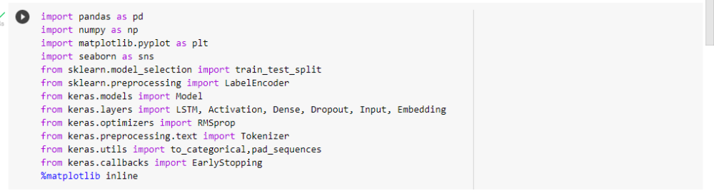

QUESTION 3:
Read dataset and do pre-processing
df = pd.read_csv('/content/drive/MyDrive/spam.csv/archive (1).zip',delimiter=',',encoding='latin-1')
df.head()

df.drop(['Unnamed: 2', 'Unnamed: 3', 'Unnamed: 4'],axis=1,inplace=True)
df.info()
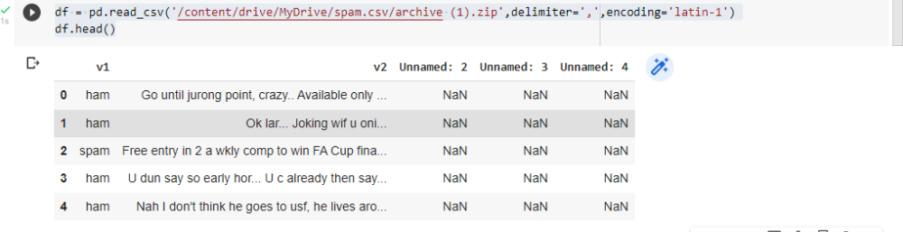
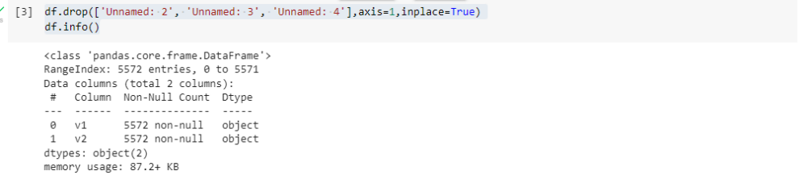

QUESTION 4:
Create model

sns.countplot(df.v1)
plt.xlabel('Label')
plt.title('Number of ham and spam messages')

X = df.v2
Y = df.v1
le = LabelEncoder()
Y = le.fit_transform(Y)
Y = Y.reshape(-1,1)

X_train,X_test,Y_train,Y_test = train_test_split(X,Y,test_size=0.15)

max_words = 1000
max_len = 150
tok = Tokenizer(num_words=max_words)
tok.fit_on_texts(X_train)
sequences = tok.texts_to_sequences(X_train)
sequences_matrix =pad_sequences(sequences,maxlen=max_len)
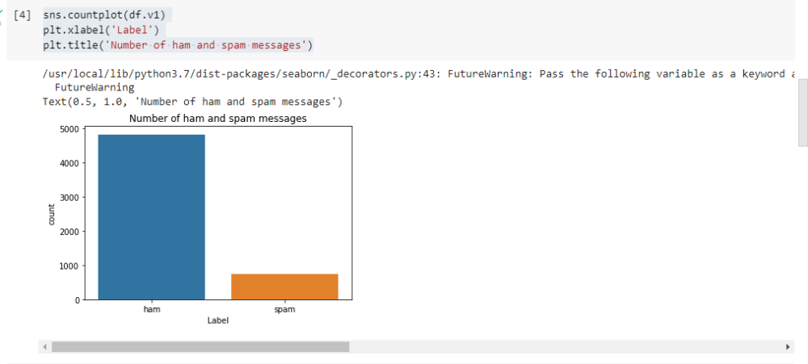
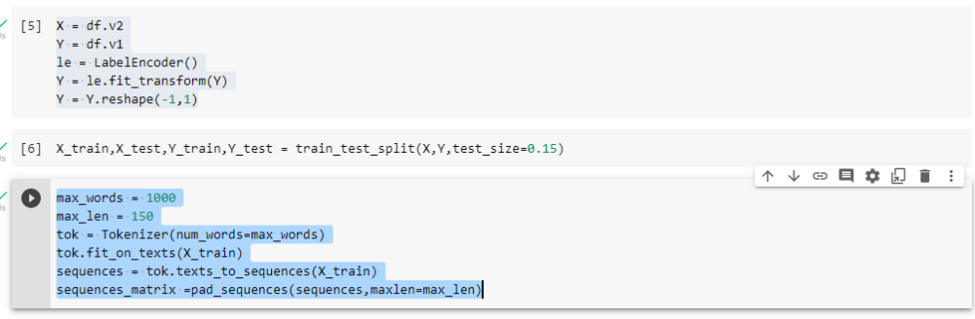

QUESTION 5:
Add Layers (LSTM, Dense-(Hidden Layers), Output)
def RNN():
inputs = Input(name='inputs',shape=[max_len])
layer = Embedding(max_words,50,input_length=max_len)(inputs)
layer = LSTM(64)(layer)
layer = Dense(256,name='FC1')(layer)
layer = Activation('relu')(layer)
layer = Dropout(0.5)(layer)
layer = Dense(1,name='out_layer')(layer)
layer = Activation('sigmoid')(layer)
model = Model(inputs=inputs,outputs=layer)
return model
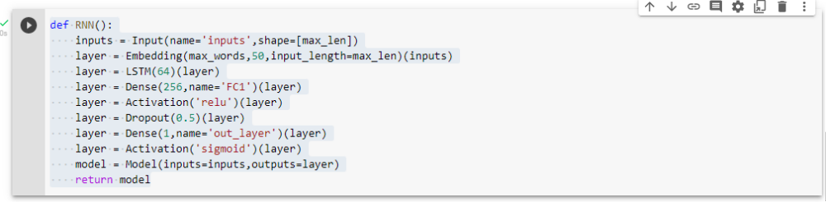

QUESTION 6:
Compile the Model
model = RNN()
model.summary()
model.compile(loss='binary_crossentropy',optimizer=RMSprop(),metrics=['accuracy'])
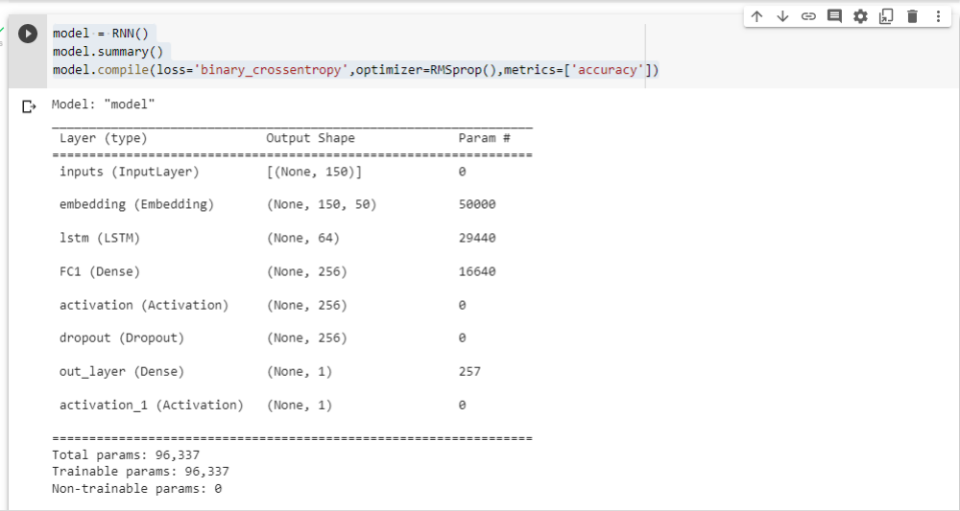

QUESTION 7:
Fit the Model
model.fit(sequences_matrix,Y_train,batch_size=128,epochs=10,
validation_split=0.2,callbacks=[EarlyStopping(monitor='val_loss',min_delta=0.0001)])

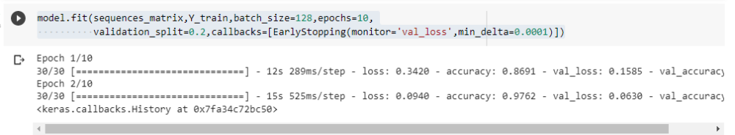

QUESTION 8:
Test The Model
test_sequences = tok.texts_to_sequences(X_test)
test_sequences_matrix =pad_sequences(test_sequences,maxlen=max_len)

accr = model.evaluate(test_sequences_matrix,Y_test)
print('Test set\n Loss: {:0.3f}\n Accuracy: {:0.3f}'.format(accr[0],accr[1]))
